Practical - 1

Aim : -
Simulate a real-time office environment where employees located in the same department need to exchange files and communicate seamlessly over a local network. Validate end-to-end connectivity and investigate how the internal network infrastructure supports this Communication.

Theory: -
In a real-time office environment, employees in the same department require a Local Area Network (LAN) to share files, applications, and communicate efficiently. A LAN connects multiple computers using switches, routers, and cabling (Ethernet/Wi-Fi). Protocols like TCP/IP, SMB, FTP, and VoIP support file transfer and communication.
To validate end-to-end connectivity, tools like ping, traceroute, and filesharing tests are used. The internal network infrastructure (switches, routers, firewalls, DHCP, DNS) ensures address assignment, routing, access control, and reliable data transmission, enabling seamless collaboration within the office.

Output: -
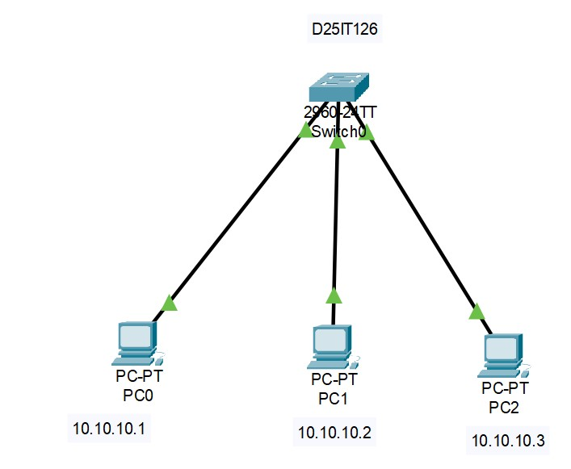
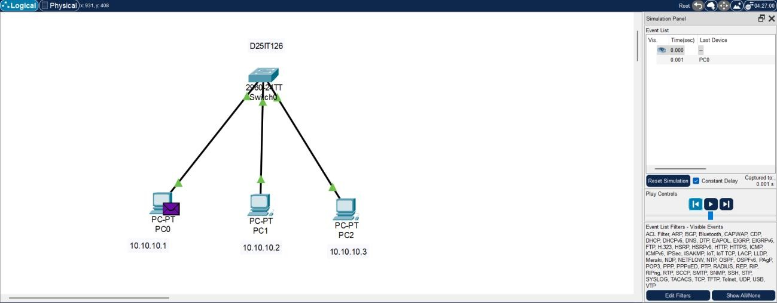

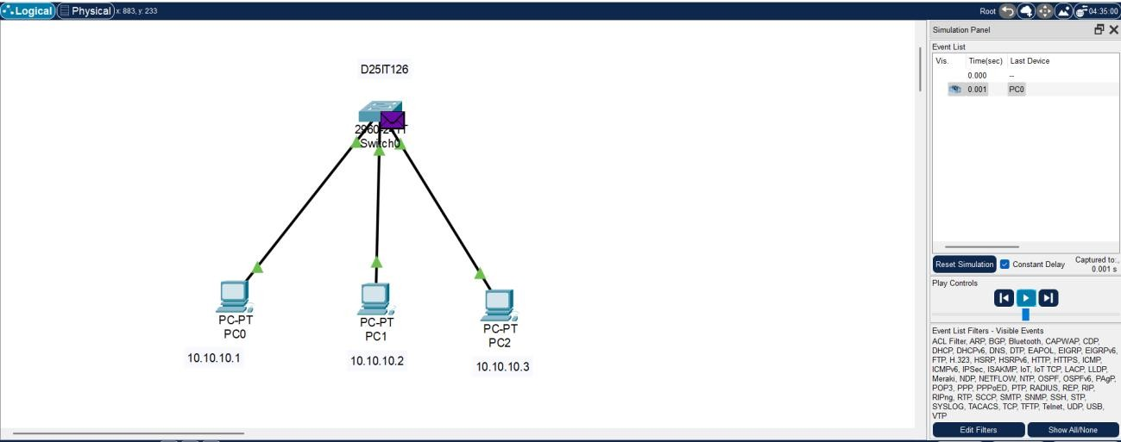

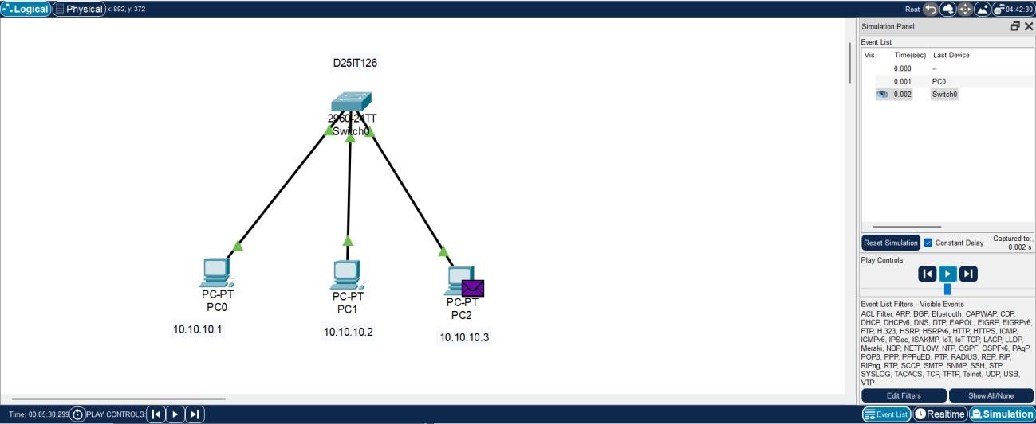

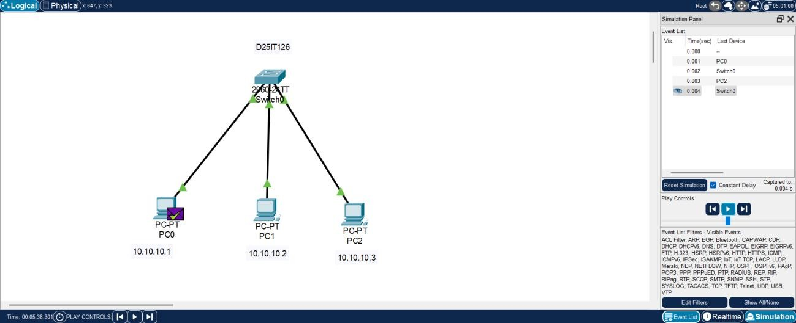

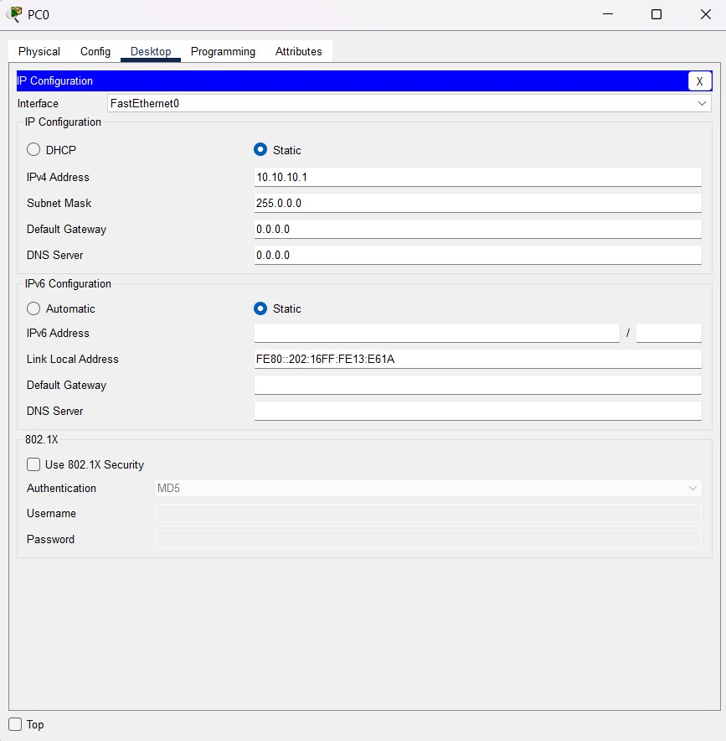

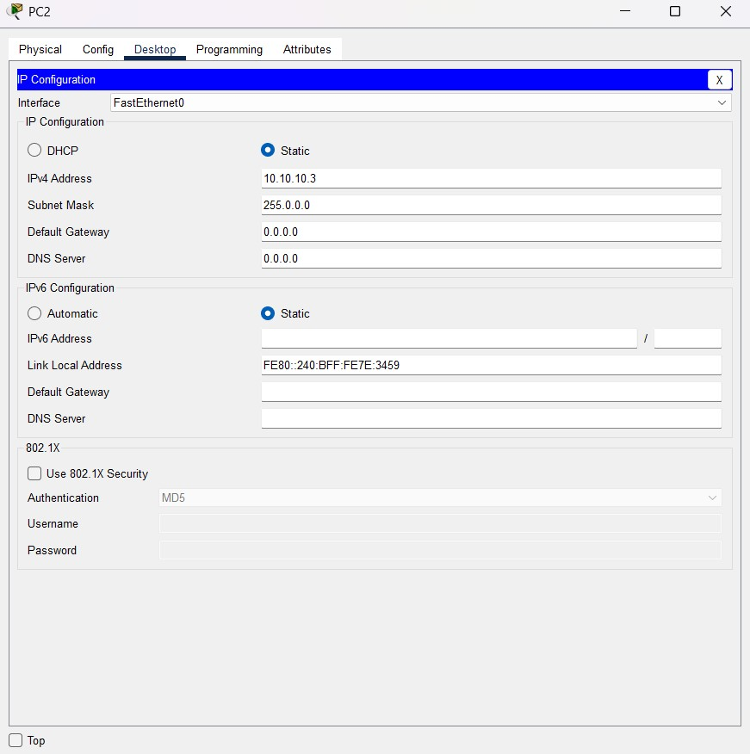
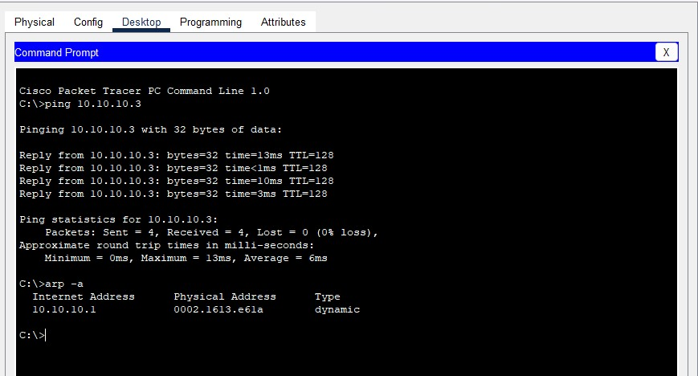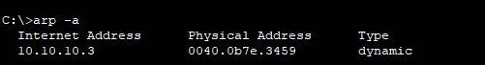

Conclusion: -
A well-structured internal LAN allows employees in the same department to exchange files and communicate seamlessly. Proper configuration of IP addressing, routing, switching, and protocols ensures end-to-end connectivity. This infrastructure improves efficiency, collaboration, and productivity in real-time office operations.

Q & A : -
Q1. What type of network is suitable for employees within the same department?
A: A Local Area Network (LAN).
Q2. Which device primarily connects multiple computers in the same office?
A: A network switch.
Q3. How can you validate end-to-end connectivity between employees’ computers?
A: By using tools like ping and traceroute.
Q4. Which protocol is commonly used for file sharing in a local office environment?
A: SMB (Server Message Block) or FTP (File Transfer Protocol).

